Adventure in the Channel
Jeff Stansfield

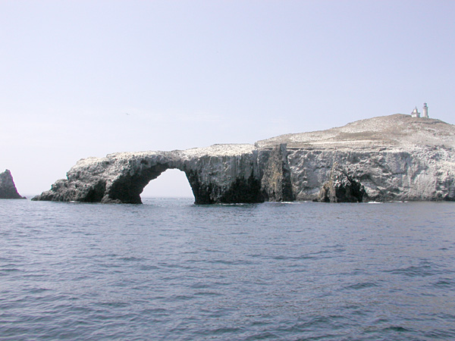

Now for a Santa Barbara Channel sea story: On March 8th I organized a family gathering to celebrate my Mother’s life and give her the burial at sea she requested (she passed away Dec 19th). Ten members of our small family came from as far away as Boston to pay their respects. My small sailboat No Fear could not carry the entire group on the 15 mile journey to Arch Rock. I needed a larger boat and my good friend Norris Leap came to the rescue, “no problem Jeff, happy to help” was the offer and I accepted. The weather predictions were sunny, wind predictions were 5 to 10 knots NNW building to 15 in the afternoon. Again “no problem, the Double LL can handle that and more” said the captain. We loaded the group on the boat, including my 83 year old Aunt, Erica my pregnant daughter and my 2 year old grandson and departed VYC at 10:00 AM. The trip out to Anacapa was smooth and we anchored behind Arch Rock to tell family stories, drink Champaign and eat cheese toasted bread prepared by Norris. It was a very special interlude and at 1:00 we let Elaine Stansfield’s ashes scatter into the sea.

By now the wind had begun to build from the NW and the swell was abeam for the rum line back to Ventura. Norris decided to take us through the Anacapa passage to achieve a more favorable angle back to Ventura. As we hit “Windy Lane” the roll of the big three story high trawler in the 6 foot plus swells was uncomfortable and our intrepid captain decided to drive north “to weather” and achieve an even better angle to the following seas. As we rolled in seas heading north at 12 knots the wind began to build reaching 30 knots. By now my aunt and daughter had been thrown across the cabin and were lying on the floor. Several people had their heads in various buckets and big Norris was at the helm spinning the wheel back and forth for all it was worth.

Our first attempt to head toward Ventura with the now 10 foot following seas almost proved fatal. Norris turned his 46 foot trawler toward Ventura and we began to surf down the steep (4 second interval) swells. I had moved to the starboard rail to secure a cooler and get some much needed fresh air when the unthinkable happened, we broached! As we surfed down a very large swell and hit the trough the rudders (probably out of the water) had very little effect and the ship made a dramatic turn to port. My vantage was definitely the best on the boat and as I saw water come up to the starboard rail I knew there was a good chance the boat would continue rolling and capsize. At the moment of greatest peril I felt the big diesels cut back, power back on the engines, then a dramatic counter steer and finally an abrupt turn back to weather. Thank goodness we had the big man at the wheel, acting with great skill and courage he decided it was far too dangerous to make the channel crossing and he would take us Santa Barbara instead. The course would take us into the teeth of the gale but going to weather for three hours and watching the waves break over the foredeck was nothing compared to another broach.

As we bashed our way northward the wind and waves seemed to build and then tease us with a momentary reprieve. As we approached Sterns Wharf the wind was so ferocious that the seas were blown flat. Some people at Santa Barbara Yacht Club said the gusts hit 50 knots. During the epic journey my 25 year old daughter who is 6 months pregnant was having contractions and thought she might deliver her baby 3 months early, my aunt Janet laid bruised against the cabin wall protected now by pillows, my two year old grandson was held tightly by his grandmother Martha, my nephew Shay emptied the “swill” buckets and comforted my daughter, my wife Tracy was at Norris’s side looking for the “rogue” wave that might do us in and my son Mason and I kept busy securing loose gear and supporting the captain with instrument readings of speed, direction and distance (oh yea I had to use the bucket once myself). As we pulled into the calm waters of Santa Barbara harbor I called the Santa Barbara Yacht Club, requested and then received permission to use their guest dock. I looked over at my cousin and saw she had courageously suffered through the trip but looked uncomfortable, I asked her if she was OK and she told me “I need to change my pants”. Norris later told me that the two highlights of this epic journey for him were securing a berth at the Santa Barbara Yacht Club guest dock and bringing all his passengers home safely.

When I was young my family would play games at our parties such as ping pong and charades. We also played a game of “levitation” where a family member would lie stiff on the floor and each of us would place two fingers under their body and lift them off the ground. After the adventure in the channel my sister Lesley and I decided that our mother saw us in peril and placed her fingers under the boat to levitate us and prevent the capsize that should have occurred.

The return journey for the Double LL proved to be even more hazardous to ship than the storm. In calm seas and a bright sunny day she hit an underwater object that damaged both props, blew out one transmission, bent a propeller shaft and maybe more. She was towed to Anchors Way Boatyard where a surveyor will assess the damage and Andy and his crew will get to work repairing the Double LL for her next adventure…

