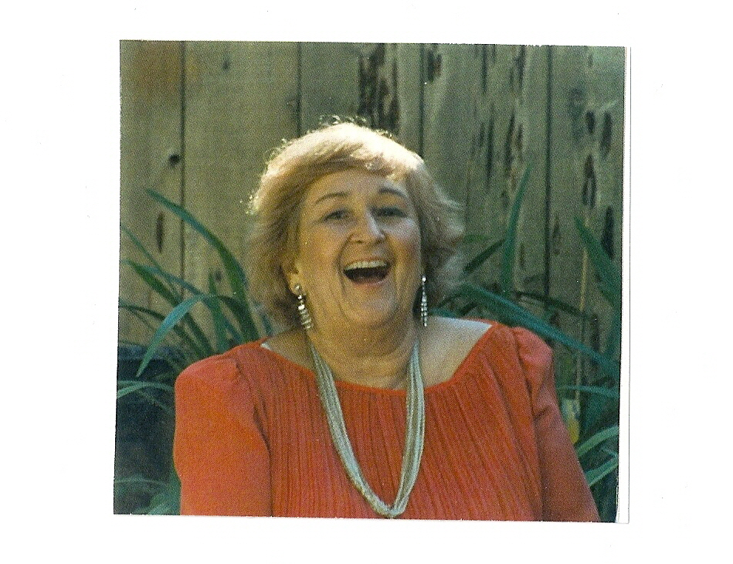

Celebration for Elaine Stansfield
1921 to 2007

On March 8 2008, Elaine’s closest family will set sail for Anacapa Island to say farewell. Elaine loved animals and spoke up for their rights most of her life. In the waters not far from a sea lion rookery in the Channel Islands National park we will scatter her ashes as she wished us to.

Date: March 8, 2008
Time: 10:00 AM
Place: Ventura Yacht Club
Itinerary: One and a half hour trip to Anacapa Island aboard Norris Leap’s 48 foot power boat the Double LL.. Champaign toast, hors d’oeuvres words from Jeff and anyone else., then the return trip to Ventura. Afterward we invite you to come to Tracy and Jeff’s for cocktails and dinner.

- We will meet at the Ventura Yacht Club, 1755 Spinnaker Dr. Ventura CA 93001. At 9:45we will board the Double LL for the 18 mile channel crossing. The Santa Barbara Channel can be rough and if you are prone to motion sickness, you should take precautions. Dramamine is an effective over the counter medication and the scopolamine patch is the best prescription medication.
- If you would like to stay in Camarillo or Ventura on Friday night before the celebration or afterwards on Saturday night, Lesley and I would insist on getting you a room at a local hotel.
- Directions to Tracy and Jeff’s house:

- Take 101 to Las Posas Rd exit and turn right (if coming from the South) or left (if coming from the North) at freeway off ramp
- Continue on Las Posas Rd for .6 miles
- At the intersection of Earl Joseph Dr. and Las Posas Dr continue straight and bear right up the hill for .3 miles, you are now on Crestview Ave as Las Posas Rd turns into Crestview Ave here)
- At the top of the Crestview Ave hill turn right (through a yield sign) onto Valley Vista Dr and continue up the winding hill for 1 mile
- Near the top of the hill turn left on Calle Aurora (a fire station is on this corner) and proceed slightly downhill for .2 miles
- Turn right on Via Del Cerro and immediately turn right into the first driveway (we are the corner house) you have arrived at 560 Via Del Cerro Camarillo, CA 93010 805-389-9550 (H) 805-444-1341 (Jeff’s cell) 805-844-6645 (Tracy’s cell) 805-415-9801 (Mason’s cell)

